Employee Campaign Coordinator Guide

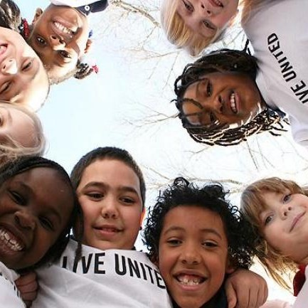The Goals
To organize and engage employees in United Way of Greater High Point’s annual campaign to improve lives and build a stronger community for us all.

Key Responsibilities
- Develop an effective campaign strategy including dates, goals, etc.
- Coordinate campaign kickoff events
- Encourage employee participation
- Educate employees about United Way of Greater High Point
- Be creative and have fun!
- Remember to say, “Thank you!”

Your Campaign Checklist

Prior to the Campaign
- Meet with United Way team member to develop a campaign strategy, timeline and goals, and to obtain campaign materials.
- Meet with your CEO/Leadership to confirm involvement.
- Review past performance & calculate a goal.
- Establish a campaign timeline.
- Publicize the campaign.

During the Campaign
- Kick off your United Way campaign.
- Kick off your United Way campaign!
- Host employee meetings with United Way representation and agency speakers.
- Show United Way campaign video in person or virtually.
- Follow up with employees unable to attend.
- Organize special events.
- Share your campaign photos and news with United Way of Greater High Point. We will brag about you and your company online!

After the Campaign

- Gather pledge forms, tabulate results on United Way pledge listing Excel spreadsheet and complete Campaign Reporting envelopes.
- Meet with United Way team member for campaign wrap-up.
- Thank your committee and employees who participated.
- Encourage CEO to thank committee and employees.
- LIVE UNITED all year round!
You have the tools!

Visit “Campaign Tool Kit” at unitedwayhp.org for materials, instructions and promotional items.

Questions? United Way staff is here to help! Call us at 336.883.4127

Questions? United Way Campaign Team Staff Directory

Joe Barnes: joe.barnes@unitedwayhp.org
Gart Evans: gart.evans@unitedwayhp.org
Kristin Faust: Kristin.faust@unitedwayhp.org
Jane Liebscher: jane.liebscher@unitedwayhp.org
Carson Spering:carson.spering@unitedwayhp.org
Mary Vaughn: mary.vaughn@unitedwayhp.org
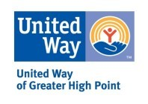Cindy Westmoreland: cindy.westmoreland@unitedwayhp.org

